**Code:**

import java.io.*\**;

import java.util.*\**;

public class JavaLabFat {

public static void main(String[] args) throws IOException, ClassNotFoundException {

*try* {

Scanner sc = *new* Scanner(System.in);

Scanner sc1 = *new* Scanner(System.in);

System.out.print("Enter number of mobile phones: ");

int n = sc.nextInt();

mobile marr[] = *new* mobile[n];

File obj = *new* File("/home/subham/Desktop/JAVA LAB FAT/mobilephone.txt");

FileOutputStream fout = *new* FileOutputStream(obj);

ObjectOutputStream objout = *new* ObjectOutputStream(fout);

System.out.println();

*for* (int i = 0; i < n; i++) {

System.out.println("-----ENTER DETAILS OF Mobile " + (i + 1) + " -----");

System.out.print("Enter name of model: ");

String modelName = sc1.nextLine();

System.out.print("Enter number of model: ");

String modelNumber = sc1.nextLine();

System.out.print("Enter name of brand: ");

String brandName = sc1.nextLine();

System.out.print("Enter price of model: ");

int price = sc.nextInt();

System.out.print("Enter quantity of the model available: ");

int quantityAvailable = sc.nextInt();

marr[i] = *new* mobile(modelName, modelNumber, brandName, price, quantityAvailable);

objout.writeObject(marr[i]);

System.out.println();

}

objout.close();

fout.close();

System.out.println();

FileInputStream fin = *new* FileInputStream(obj);

ObjectInputStream objin = *new* ObjectInputStream(fin);

mobile mInputArr[] = *new* mobile[n];

*for* (int i = 0; i < n; i++) {

mInputArr[i] = (mobile) objin.readObject();

}

objin.close();

fin.close();

System.out.println("---------SELECT AN OPTION-------");

System.out.println("1.View details of mobile phone by brand name");

System.out.println("2.View details of mobile phones within a price range");

System.out.println("3.View the brand that has highest number of models with price less than Rs.10000/-");

System.out.print("Enter you choice: ");

int ch = sc.nextInt();

*switch* (ch) {

*case* 1*:*

mobile.viewDetailsByBrandName(mInputArr);

*break*;

*case* 2*:*

mobile.viewDetailsWithinPriceRange(mInputArr);

*break*;

*case* 3*:*

mobile.viewBrandsWithHighestModelsLessThan10k(mInputArr);

*break*;

*default:*

System.out.println("Enter a valid option");

}

sc.close();

sc1.close();

} *catch* (InputMismatchException e) {

System.out.println("Please eneter the input of correct type");

} *catch* (Exception e) {

e.printStackTrace();

}

}

}

class mobile implements Serializable {

String modelName;

String modelNumber;

String brandName;

int price;

int quantityAvailable;

public mobile(String modelName, String modelNumber, String brandName, int price, int quantityAvailable) {

*this*.modelName = modelName;

*this*.modelNumber = modelNumber;

*this*.brandName = brandName;

*this*.price = price;

*this*.quantityAvailable = quantityAvailable;

}

public void viewDetails() {

System.out.println("Model Name: " + modelName + ", Model Number: " + modelNumber + ", Brand Name: " + brandName

+ ", Price: " + price + ", Quantity Available: " + quantityAvailable);

}

public static void viewDetailsByBrandName(mobile[] marr) {

Scanner sc = *new* Scanner(System.in);

System.out.print("Enter name of brand: ");

String brand = sc.nextLine();

int flag = 0;

*for* (mobile m *:* marr) {

*if* (m.brandName.compareToIgnoreCase(brand) == 0) {

m.viewDetails();

flag = 1;

}

}

*if* (flag == 0) {

System.out.println("No mobiles of the brand were found");

}

sc.close();

}

public static void viewDetailsWithinPriceRange(mobile[] marr) {

Scanner sc = *new* Scanner(System.in);

System.out.print("Enter lower range of the price: ");

int low = sc.nextInt();

System.out.print("Enter higher range of the price: ");

int high = sc.nextInt();

int flag = 0;

*for* (mobile m *:* marr) {

*if* (m.price >= low && m.price <= high) {

m.viewDetails();

flag = 1;

}

}

*if* (flag == 0) {

System.out.println("No mobiles in that price range were found");

}

sc.close();

}

public static void viewBrandsWithHighestModelsLessThan10k(mobile marr[]) {

HashMap<String, Integer> mobileCount = *new* HashMap<>();

int flag = 0;

*for* (mobile m *:* marr) {

*if* (m.price <= 10000) {

*if* (mobileCount.containsKey(m.brandName)) {

mobileCount.replace(m.brandName, mobileCount.get(m.brandName).intValue() + 1);

} *else* {

mobileCount.put(m.brandName, 1);

flag = 1;

}

}

}

*if* (flag == 0) {

} *else* {

String highestBrand = "";

int highestVal = 0;

*for* (String b *:* mobileCount.keySet()) {

String brand = b.toString();

int val = mobileCount.get(brand).intValue();

*if* (val > highestVal) {

highestVal = val;

highestBrand = brand;

}

}

System.out.println(

"The brand that has the highest number of Models with price lesser than Rs.10000: " + highestBrand);

}

}

}

**Editor Screenshot with Code and Output (IDE used - VSCODE):**

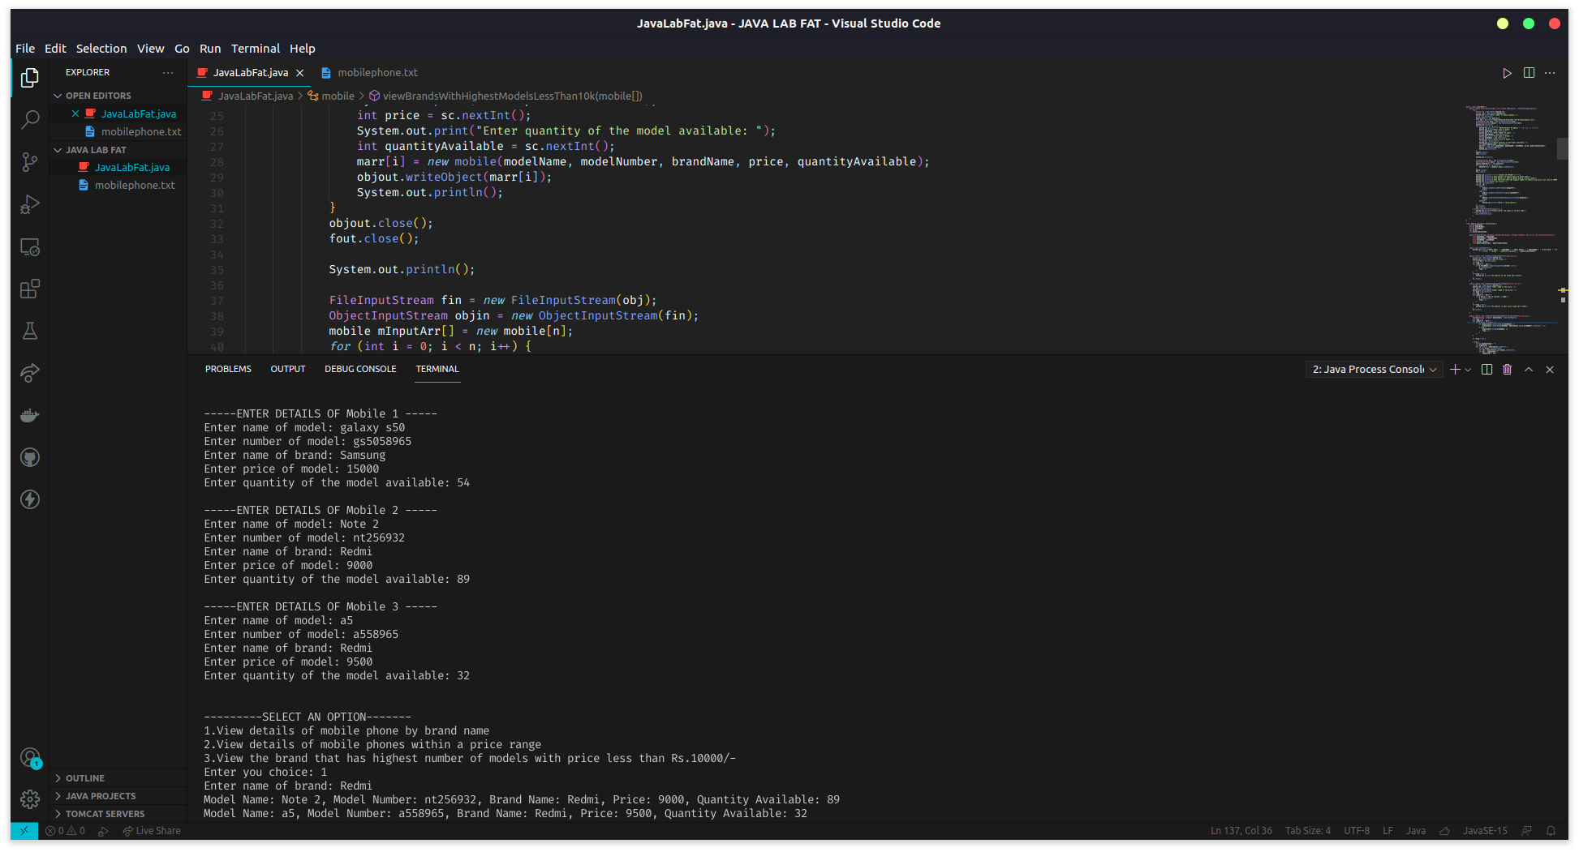

**Output:**

**1. Details of mobile phone by brand name:**

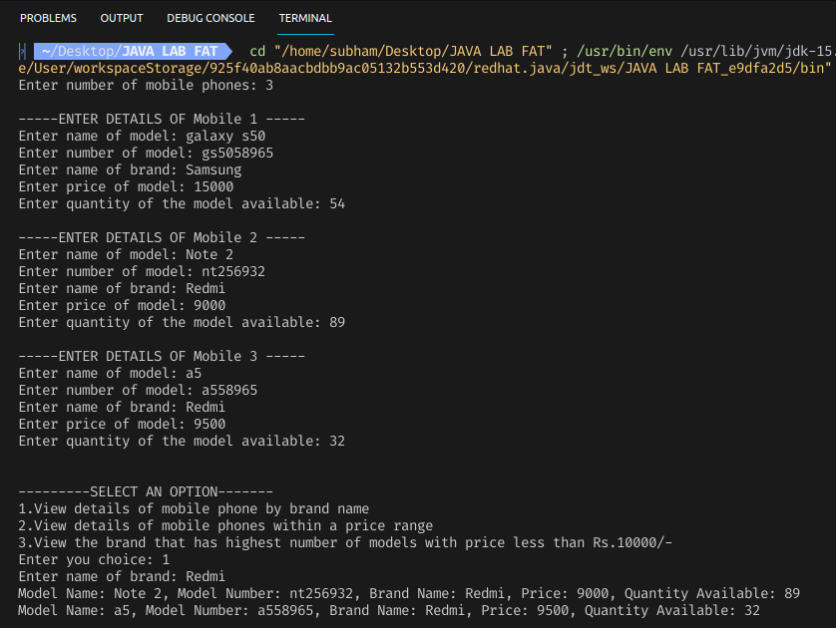

**2. Details of mobile phone within price range**

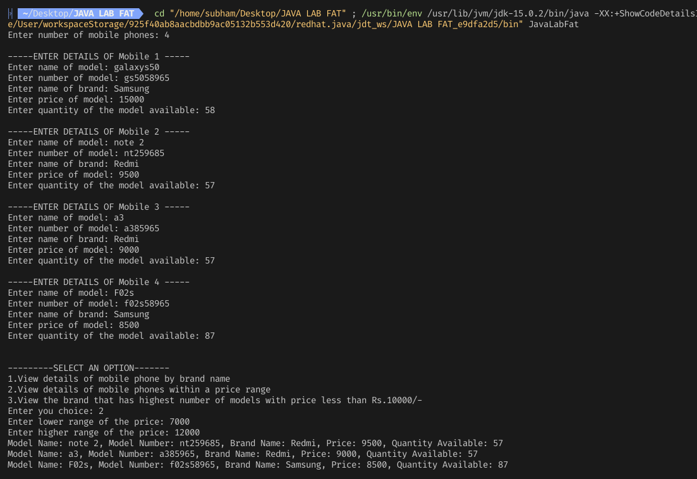

**3. Details of brand with highest models less than Rs.10000**

